
2020 RATEPAYERS REPORT
MAYORS MESSAGE

These last few months have been unprecedented times for not only our community, our province and our country but the entire world. I would like to thank the residents of our community for following the guide lines set out by our provincial government and health officials. By avoiding large gatherings and complying with social distancing we will get to better days.

Because of the Pandemic situation, we are unable to hold our annual ratepayers spring meeting. We will however have each committee chairperson give an overview of what has been happening in their department and what plans we have coming for the year ahead. In these difficult times, the business of the town must continue and are coping the best we can.

The two major projects that you will be hearing about from the respective committee chairs are the lift station upgrades which has already started, and the construction of our new swimming pool later this summer. These are both exciting projects that will greatly improve our infrastructure and quality of life.

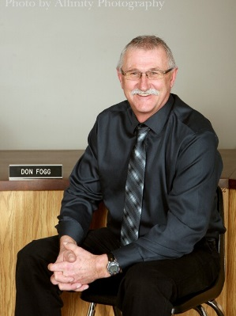
As we welcome spring, it is also great to see our residents taking pride in the appearance of their yards. A pat on the back to all of you for helping keep our community attractive and a safe place to call home.

In closing, just a reminder that this is election year. The term of this
council ends in October, please consider letting your name stand for municipal office. Enjoy your summer, watch out for one another and be safe. Thank you



D O N F O G G

EMPLOYEE RELATIONS REPORT

Committee Members – Mayor Don Fogg, Councilors – Brad Sicinski, Lorrie Popp
Kudos to Glenda and Karlis for managing the staff through the COVID19 pandemic and keeping staff within the social distancing guidelines as much as possible. They encouraged the public to deal with them via phone and online, thereby keeping staff and the public as safe as reasonably possible.
Council would also like to thank the staff for doing their best to continue working while maintaining social distancing.
A part-time staff member was hired, effective May 19, 2020, to help catch up on extra workload – eg. Cleaning out old files and setting up filing system that will serve us well in the long term.
As usual, council met with each staff member individually and are pleased to hear that staff are happy with the way things are managed by Glenda and Karlis.
All staff were given modest raises this year. Joanne W. has successfully completed all her municipal training and is working towards her certification. Congratulations Joanne.
Thanks to the outside workers, who have managed the workload for several months while one staff member off on short and long term illness. Summer workload is expected to be heavier than winter (since we had a relatively mild winter), and a plan is underway should the staff member be unable to return to work soon.


Submitted By: Chair Marion Firby



CONTACT US:
202 Wells Ave East Langenburg, SK S0A 2A0

langenburgt@sasktel.net

 306-743--2432

www.langenburg.ca.

www.facebook.com/ Town.of.Langenburg/



@townoflangenburg @lbg_recNdevelop

SANITATION & PUBLIC PROTECTION REPORT

Committee Members – Mayor Don Fogg, Councilors – Marion Firby and Jeremy Stasiak Police protection/enforcement has remained basically the same as last year.
Garbage and Recycling Collection is carried out by Ottenbreit (OSS). We may be reviewing the possibility of retendering the recycling service due to the constant charges for high contamination.
We are dropping the Recycle Coach app because of it inability to remain up to date.
We continue to put money into reserve for future upgrades of SCBA for the Fire department.

Submitted By: Chair Brad Sicisnki

FINANCE, HEALTH & ADMINISTRATION REPORT

FINANCIALS

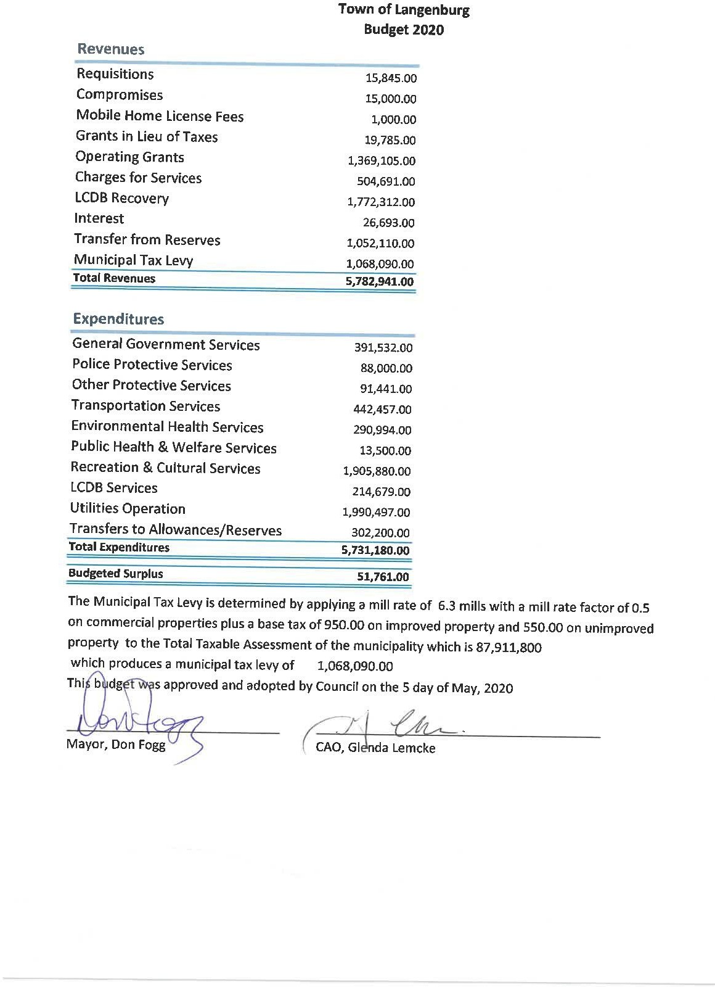
Committee Members – Mayor Don Fogg, Councilors – Don Wyand, Lorrie Popp
It is an exciting yet trying time for the Town of Langenburg. This year marks our Highest ever budgeted. Expenditure at
$5,731,180. That is no small feat for a small town! We do this by raising our Mill rate by only 0.3 and modifying our base tax increasing it by $50! The large expenditure is mostly to do with the two major capital projects beginning this year. The new swimming pool and our new lift station. Through careful planning, established reserves grants and fundraising we can accomplish these projects with the small increases mentioned above. By allocating $150 of the base tax to the new pool we can pay for the pool over the next 5 or so years. Without this increased allocation, the cost of the new pool would have increased by over $100K in interest payments alone.
This year we have budgeted for a fairly large surplus, $51,761. It was council’s intention at the time of the budget creation that this buffer was needed in the trying times of the pandemic and that any remaining surplus at the end of the year would go towards our capital project loans. This will reduce the amount of interest paid on these loans and free up capital funds sooner to go towards other infrastructure projects.
It has been a pleasure serving as a councilor for this town over the past term. I am truly honored and humbled by the experience. Would like to thank our dedicated staff for working well within our operating budgets. A Huge thank you to Glenda and Karlis for keeping us on track, and thank you to Al, Shayne, Dave, Joanne, Juli, Lina, and Joner for their patience in following the budgets allocated. We have a truly fantastic staff!

Submitted By: Chair Tanner Hunt

UTILITIES REPORT

TRANSPORTATION REPORT

Committee Members – Mayor Don Fogg, Councilors – Jeremy Stasiuk, Brad Sicininski
In 2019 the transportation portfolio had a total of $402,750.00 to spend as per the budget. Again this is the largest expense of taxpayer money of all the others departments. We spent $463,609.00 in total which was over budget but was covered by additional revenue which I will explain later in this report.
Some of the breakdown as to what is covered under the transportation heading.
Wages- $ 100,272.00
Workshop supply, services by others, insurance, license, travel, snow removal-$25,193.00
Equipment (Grader sweeper trucks) repairs $ 10,859.00 Utilities-Heat, phone, streetlights, $ 33,908.00
Supplies- Gravel, Signs asphalt, fuel, $44,965.00 Paving $ 207,119.00
Loan payments- street sweeper & paving $ 41,295.00. There was no capital expenses (Equipment purchases) in 2019.
So, you can see how quickly the maintenance and care of our infrastructure comes to be the largest expense in the budget. On the paving side we spent a larger than budgeted amount on three projects in 2019. Additional gas tax revenue sharing from the province allowed us to provide an all-weather roadway to the Health Centre. The 2020 paving budget has been set at $125,000.00. The transportation service budget for 2020 was set at $442,457.00.
Unfortunately, some of our streets are getting neglected as rising costs makes it somewhat impossible to keep up. If you are on a street that has cast water lines, we will not be looking at paving until we are able to replace the aging lines. This is going to be awfully expensive and we are hoping infrastructure money will be made available from the federal and provincial governments in the near future. Just a gentle reminder that the municipal elections are scheduled for this fall. If you have an interest in serving your community to make it the best small town in Saskatchewan give it some thought.
Committee Members – Mayor Don Fogg, Councilors – Marion Firby and Tanner Hunt
A pumping station is made up of a large tank, known as a wet well, that acts as the receiver for sewage from a building or a group of buildings. Sewage from individual houses flows into the wet well. The sewage will then sit in the well until it reaches a predetermined level. Once it reaches this level, a pump will kick in to pressurize the sewage so that it will travel out of the wet well, uphill, to a point where it enters the main sewer, or that it can then travel into the main sewer using gravity.
In 2014 the Town of Langenburg applied for the Federal/Provincial/Municipal Funding grant known at that time as the Building Canada Fund (current program is Investing in Canadian Infrastructure Program (ICIP).
After 5 years of waiting council received final confirmation that the town would be getting funding under the grant. After several months of paper work and filling out agreement for the funding was announced by the Federal and Provincial government and the town was able to begin the tendering process. In early 2020 the tendering process was completed and Hipperson Construction was awarded the contract. In May work began on preparing for the demolition of the current building. Although funding for this agreement will not be quite the 1/3 Federal 1/3 Provincial 1/3 Municipal we had anticipated based on how long it took to receive the funding the grant is a great asset to the project. Since the municipality has built a fairly adequate reserve and does not foresee needing to raise taxes or fees to fund this current project at 1,625,000.
Langenburg: Sewage pumping system upgrades (PTIC-
SCF)
Government of Saskatchewan: $439,333 Town of Langenburg: $439,334 Government of Canada: 439,333

Thank you for those who have commented on the positive things we have been able to do with the funds available. We could do more but it takes more resources than we can justify by raising taxes.

Submitted By: Lorrie Popp
Total project eligible costs: $1,318,000

This project will construct a new pump chamber to convert the existing dry well into wet well storage capacity.

Submitted By: Chair Don Wyand

THIS DOCUMENT ALONG WITH A YEAR IN REVIEW FOR THE RECREATION DIRECTOR AND COMMUNITY DEVELOPMENT OFFICER WILL BE MADE AVAILABLE
ON THE WEBSITE AND OUR SOCIAL MEDIA PLATFORMS FOR YOU TO REVIEW.


RECREATION, CULTURAL SERVICES &
DEVELOPMENT REPORT

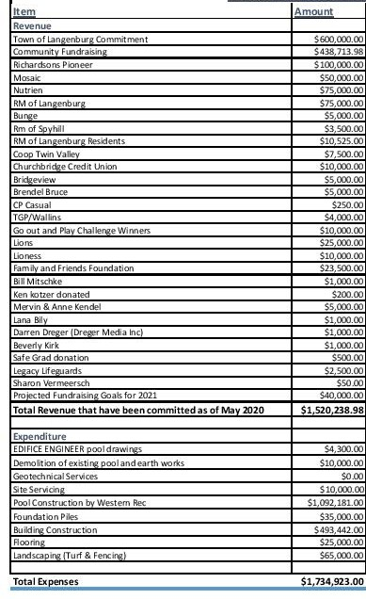
NEW POOL PROJECT BUDGET

Committee Members – Mayor Don Fogg, Councilors – Don Wyand & Tanner Hunt
With the onset of the covid-19 pandemic, it has been a very trying start to the year for recreation in Langenburg. Unfortunately it has forced the closure of all public rec facilities and the cancellation of several sports seasons and programs. I would like to thank everyone in and around our community for their continued efforts in maintaining your safety and the safety of others.
Also a big thank you for your patience as we as a council, our administrative staff and our maintenance staff try our very best to continue to provide essential services and get our jobs done, while ensuring public safety. This has certainly been an unprecedented experience for all!
The recreation budget for 2020 carries the largest portfolio among committees, due to the ground breaking of our new swimming pool! Construction is set to commence with the demolition of our existing facility in early August of this year. Our recreation budget comes to a total of
$1,905,880 , broken down as follows.
Facilities operations - $103,853 This includes the operating and maintenance costs of our indoor and outdoor rec facilities, parks and library.
Community development - $27,230 This is funding for a variety of projects undertaken by our community development office.
Grants and donations- $21,00 These are funds injected into our regional park and library.
Capital outlay -$1,747,798 This money comes from a few sources . The largest portion coming in the form of grants and donations procured by the tireless efforts of the new swimming pool committee and rec director. Secondly a
$600,000 commitment from the Town of Langenburg. And the third will be in the form of a loan which will be taken by the town on behalf of the pool committee and be repaid by further grants and fundraising efforts. Juli Mitschke, our rec director, will provide a much more detailed breakdown of the new pool project. Also in the capital outlay, is a budgeted $15,000 which will be put toward the start of a proposed walking path system which we plan on expanding in years to come.
Economic development -$6,000 This is an annual contribution to the business facade program. If you are an existing or potential new business owner and haven’t heard of this program, I encourage you to reach out to Lina, our economic development officer.
As a representative of the Town of Langenburg on the Langenburg Community Development Board, I’ll breakdown the budget items we contribute to the board.
Salaries -$188,859 These are the salaries of our recreation and economic/community development offices,as well as our caretaker. Board expenses -$25,820 This is the contribution to the board to cover operating costs. Our contributions to the LCDB total $214,679

I would like to extend a thank you to each and every one of our town staff, recreation and economic/community development staff and my fellow members of council. Last but certainly not least, thanks to the volunteers of our community for the many many hours you put into Langenburg’s recreation! As others may have mentioned, municipal elections are approaching. I do encourage anyone who has an interest in keeping our town an amazing place to call home, to consider running for council. Having grown up just down the road and living here for the better part of four years, I am very proud to call Langenburg my new home and look forward to raising my family here!

Submitted By: Chair Jeremy Stasiuk

